Project Design Phase
Problem – Solution Fit Template

Date | 15 February 2025
Team ID
Project Name
Maximum Marks | 2 Marks

Problem – Solution Fit Template:
The AI FAQ Assistant addresses the common problem of users spending time searching for answers to frequently asked questions. By using AI and Natural Language Processing (NLP), the system understands user queries and provides relevant answers from the FAQ database or knowledge base. This improves response time, reduces repetitive support work, and provides a convenient way for users to access information.
Purpose:
- Solve user problems: Provide quick and relevant answers to frequently asked questions.
- Improve solution adoption: Offer a simple chat-based interface that users can easily access.
- Improve communication: Understand different forms of user questions and provide clear responses.
- Reduce repetitive work: Handle common queries automatically and reduce the workload of support staff.
- Improve user satisfaction: Provide faster, convenient, and consistent access to information.
Template:
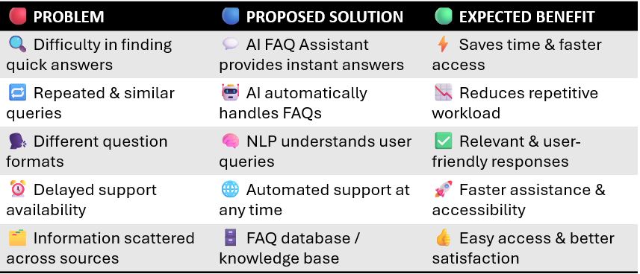
References:
- https://www.ideahackers.network/problem-solution-fit-canvas/
- https://medium.com/@epicantus/problem-solution-fit-canvas-aa3dd59cb4fe

